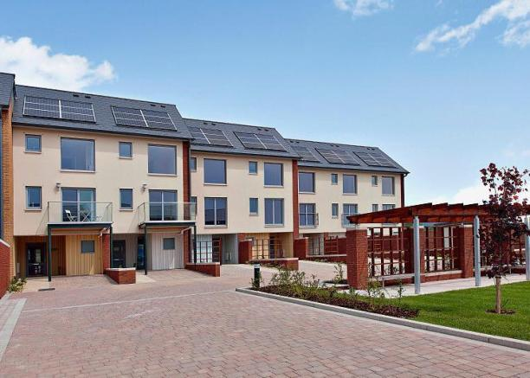

**Harbour View Residential Development – 30 Residential Units**

**Design, manufacture and erection of 30 three storey town houses in four blocks in the SA1 area of Swansea. Constructed in 2010, Seven Oaks provided the timber frames, floor cassettes and roof structures for this luxury eco development which incorporates our Triso-Warm hybrid SIP panel system. The development was designed to code for sustainable homes level 4.**

**Type of Project - Residential**

**Client – Hale Homes**